**以微處理機為基礎之鋰鐵電池容量估測系統**

**Develop Microprocessor Based Capacity Estimating System for LiFePO4 Battery**

|  |  |  |  |  |  |  |  |
| --- | --- | --- | --- | --- | --- | --- | --- |
|  | 卓明遠1 | 1 | 1 | 蕭維誠1 | 李建興2 |  | |
|  | Ming-Yuan Cho |  |  | Wei-Cheng  Hsiao | Chien-Hsing  Lee |  | |
| 1國立高雄應用科技大學  Department of Electrical Engineering National Kaohsiung University of Applied Sciences | | | | | | |
| 2台灣中油股份有限公司  Chines Petrleum Coorporation,Taiwan | | | | | | |

**Abstract**

The paper of this thesis is to apply the technologies of battery capacity measurement, microprocessor/hardware, and web based programming to develop a prototype of Battery Management System (BMS). The main goal of this thesis contains establishment and analysis of battery charging/discharging curve, close loop load voltage associated with look up table method to estimate the battery residual capacity. Meanwhile, the column method is adopted to measure and calculate the incremental battery capacity during charging period. Voltage/current extracting circuit and microprocessor based module are developed to integration and testing. Finally, this web based BMS is designed to communicate with microprocessor via Modbus protocol and display battery information on its Graphical User Interface (GUI). The practicality of the proposed system has been justified by the proposed system testing.

Keywords：LiFePO4 battery, close loop load voltage method, column method, microprocessor, battery management.

1. Introduction

With the increasing development of technology, humanity for the excessive use of fossil fuels, resulting in environmental pollution and global climate change, however, in order to reduce the use of fossil fuels, the environmental damage, "carbon reduction" development and renewable energy will become an important trend in the world of development, so green energy and electric vehicles to promote the R & D focus, batteries naturally became a very important renewable energy generation in the energy storage element. Advantage of the large current charge and discharge characteristics of lead-acid batteries currently on the market is still large capacity energy storage components, mainly due to lower prices and skilled, but there is lithium iron battery, such as lead-acid batteries can not reach the [1-2], making In recent years, lithium-iron battery electric steam locomotive became a source of power indicators. Therefore, this paper lithium iron battery measurements, establish a good battery capacity detection system with battery management interface, allowing users to accurately understand the current real-time information of the battery, when the residual capacity and increased capacity rechargeable batteries tired, estimate the state of the battery so that the battery in the more efficient operation. Once the battery has a good measurement information platform and surrounding facilities, promotion of electric cars and motorcycles will be just around the corner.

2. lithium iron battery and battery equivalent circuit

2.1 lithium iron battery works

Lithium iron battery is charging, the positive electrode of lithium-ion (Li +) penetrate through the polymer membrane to the anode migrate; during discharge, the negative electrode of lithium-ion (Li +) migrate through the membrane to the cathode as shown in Figure 1 below. Lithium-ion batteries are also due to the migration of lithium ions back and forth in the charging and discharging for this name.

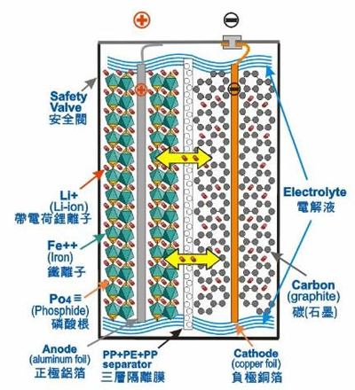

Figure 1 Figure internal structure of lithium-iron battery [3]

Lithium iron battery has the following advantages: 1 cycle life and high 2. fast charging high conversion efficiency 3 4 5 low cost no memory effect 6 pollution.

**2.2 Battery Equivalent Circuit**

Equivalent capacitance model shown in Figure 2, where the open circuit voltage of the battery Vbc, Rsd for self-discharge resistance, its value and the battery terminal voltage, the initial battery capacity, temperature, quite sensitive to temperature changes.



Figure 2 battery equivalent capacitance model [4]

Thevenin equivalent capacitance model correction model for other schools did not consider missing battery self-discharge phenomenon, shown in Figure 2 presents the battery self-discharge phenomenon, and to R, C parallel circuit to replace the Thevenin model ideal voltage source.

A battery open-circuit state, the internal battery will be forming the circuit, the discharge in the inside of the slow behavior when the temperature rises, a violent chemical reaction within the battery, so that the self-discharge rate will be more serious, and since the discharge condition of the battery itself is discharged from the the size of the resistance value to performance. Under normal conditions, the self-discharge resistance inversely proportional to temperature, and battery open circuit voltage is inversely proportional, inversely proportional to the remaining battery capacity. Figure 2 is a battery storage capacitor Cbc, Cov in parallel with R1 and the Thevenin model of the same, to effect the performance of the battery over-voltage, when the battery charge and discharge, the terminal voltage rise and fall phenomenon.

Table 1 compares the advantages and disadvantages of battery capacity detection method [11,12]

|  |  |  |
| --- | --- | --- |
| 方法 | 優點 | 缺點 |
| 比重法 | 與電池電容量有線性關係 | 1.無法使用於密閉式電池。  2.充放電後需花時間等待 才能量測電解液比重。 |
| 開路  電壓法 | 容易實現，且準確估測初始電容量。 | 1.僅能量測電池初始電量，無法檢測電池接下來充放電過程，  2.且需等待開路電壓回穩 |
| 加載  電壓法 | 容易實現，且成本低。 | 1.只適用於單一輸出電流狀態。  2.不適合用於電流變動較大之負載檢測。 |
| 查表法 | 增加多條放電曲線，使準確度提高，易實現。 | 1.準確度只略高於加載電壓法。  2.用於電流變動較大負載下，準確度仍有限。 |
| 庫倫法 | 適用於各種電池。 | 初始容量無法得知，需搭配其它方法使用。 |
| 內阻法 | 電池內阻隨環境因素變化，不需修正電池狀態與環境因素。 | 電池內阻小，不易量測。(毫歐姆等級) |

**3 battery capacity detection and characteristic curve established**   
**3.1 Battery capacity test**  
Battery capacity detection process due to a wide range of batteries and made ​​of different materials and the internal structure of the composition, so each one has a unique battery charge and discharge characteristics, so the charge for the batterydischarge characteristics do fully understand, the selection of the most detecting the battery capacity suitable manner. Which contains specific gravity method [5], opencircuit voltage method [6], closed-loop voltage method [7], look-up table method [8],Coulomb law [9], as well as resistance method [10] and made of paper, batteriescapacity detection method.

**3.2 discharge characteristic curve established**

This article uses closed loop load voltage method to measure residual capacity battery, car lithium iron batteries 0.3C ~ 2C and motorcycle batteries 0.3C ~ 1C constant current discharge, and transfer voltage and current values ​​to retrieve the computer. It retrieves data will be used to establish the battery terminal voltage and discharge capacity of the table during discharge.

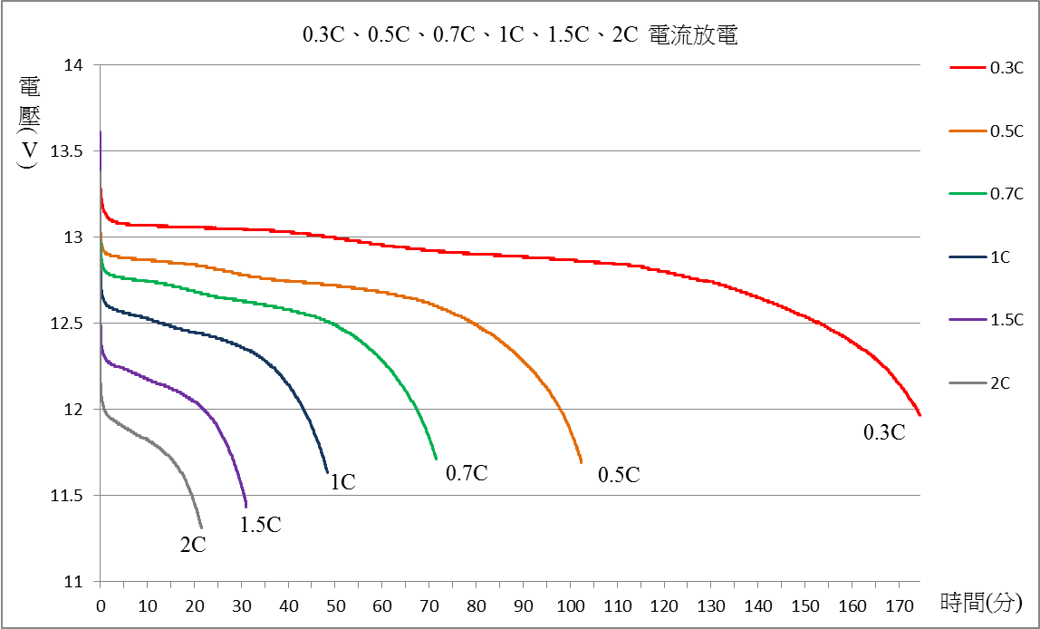

Figure 3 car lithium iron batteries for a variety of current discharge voltage curve of

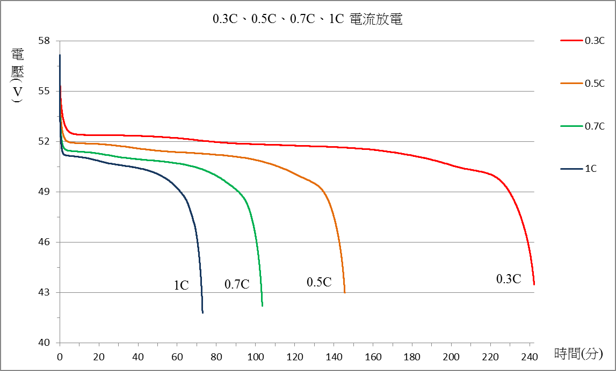

Figure 4 locomotive lithium-iron batteries for a variety of current discharge voltage curve of

**4 battery residual capacity and tired increase capacity estimation system**

**4.1 battery capacity estimation system architecture**

Figure 5 is the battery capacity estimation system architecture diagram, set the three-stage switch charge and discharge switch, and retrieve the circuit through the front battery parameters after voltage, current capture, using microprocessor DSPIC as computing core, with lithium iron remaining battery power and increase the capacity estimate tired firmware design, various parameters and estimate the battery capacity through RS-485 will be transferred to the PC real-time information displayed on the web



Figure 5 battery capacity estimation system architecture diagram

**4.2 specification lithium-iron batteries**

Lithium iron batteries currently on the market many brands, each manufacturer uses positive and negative, different electrolyte material quality and process, its performance will vary as a type lithium iron battery capacity will differ. Through experimental test battery charge and discharge, the battery charge-discharge test curve to understand the actual characteristics, improved battery capacity estimation accuracy.

Table 2A Car lithium iron battery and lithium-iron battery B brand of motorcycle specifications

|  |  |  |
| --- | --- | --- |
|  | C:\Users\Administrator\AppData\Local\Microsoft\Windows\Temporary Internet Files\Content.Word\10419402_923502214327762_8146535510402943282_n.jpg | C:\Users\Administrator\AppData\Local\Microsoft\Windows\Temporary Internet Files\Content.Word\10487210_923474317663885_4573877813194070594_n.jpg |
| 名稱 | A牌汽車鋰鐵電池 | B牌機車鋰鐵電池 |
| 標稱電壓 | DC 13.2V  (單顆3.3V、4串) | DC 48V  (單顆3V、16串) |
| 標稱電容量 | 20Ah | 10Ah |
| 充電電壓 | 14.6V | 58.4V |
| 截止電壓 | DC 10~12V | DC 38~42V |
| 建議  充電電流 | 1C | 1C |
| 最大持續放電電流 | 300A (15C) | 30A (3C) |
| 最大瞬間放電電流 | 400A<1秒 | 33A<1秒 |
| 操作溫度 | -20~75 | -20~55 |
| 保護裝置 | BMS | BMS  (外加40A保險絲) |
| 重量 | 4.5Kg | 8.5Kg |

**4.3 battery residual capacity estimation algorithm and tired increase capacity**

This system will be mainly residual capacity estimation method using closed circuit voltage method with a lookup table for battery electric battery residual capacity estimation, supplemented by Coulomb measurement method to estimate the cumulative increase battery power, following the methods for planning and design details of the presentation.

**(1) remaining battery capacity estimation algorithm**

When using closed-loop load voltage discharge method, by measuring the average discharge voltage of the battery after a short time after, that the residual capacity of the battery via a look-up table and interpolation. The closed loop voltage to achieve, must understand the characteristics of the relationship between the battery terminal voltage value of closed loop with the remaining capacity, the establishment of a control voltage and capacitance table (look-up-table), so the previously conducted experiments to understand the battery discharge the battery discharge characteristics is a very important part.

Table 3 car batteries to power 0.5C discharge residual voltage control with the end of the table



Table 4 locomotive residual capacity at 0.5C discharge current of the battery terminal voltage control table



The above automotive and motorcycle battery "0.5C" current discharge, for example, 10 to 20, followed by a discharge current of 0.5C under an average capacitance value of the output status can be calculated based on the capacity of 0% to 99% of each discharge the relationship between the average terminal voltage of the battery and the establishment of the residual battery charge% and the average terminal voltage of the table, and the residual power estimation program is written as shown in Figure 6 to estimate the microprocessor module.



6 lithium-iron battery residual capacity estimation programming flowchart of FIG.

**(2) increase the battery capacity estimation algorithm tired**

Using coulometry (method ampere-hours) for the higher accuracy of the capacitance detection. When the battery is that the battery residual charge with a lookup table through the closed loop load voltage method to begin charging, and an initial capacity (Ah) continues ampere hours accumulate, when to get tired of the rechargeable battery will last incremental capacity (Ah) value is converted to actual capacity%.

Where t is the current charge time, tn for the initial time, tn + 1 to the current time, C (tn) is the initial capacitance, C (tn) for the current consumption, i (tn + 1) is the charge current. In the microprocessor computing power using discrete cumulative and incremental tired of this flow chart in Figure 7 written estimate microprocessor computing modules, charging tired increase capacity computing.

(1)



Figure 7 lithium-iron battery tired incremental design flow estimation program

**4.4 Battery capacity detection hardware design**

**(1) voltage and current Capture Circuit Design**

Figure 8 is a capture circuit uses locomotives, automobiles two voltage and current Capture loop, using two sets of circuits capture circuit can improve its measurement accuracy. The first group of motorcycle lithium-iron battery (10Ah, 48V) to retrieve the circuit, the voltage setting range is 40V ~ 59V, the current maximum of 10A (1C); capture the second set for automotive lithium-iron battery (20Ah, 13.2V) circuit, the voltage setting range is 11V ~ 15V, the current maximum of 40A (2C), which due to fast car rechargeyour current up to 40A (2C), so the diameter capture circuit using 8mm2 maximum flow resistance of the cable 60A.



Figure 8 circuit voltage and current Capture

This module mainly microprocessor (MCU) shown as arithmetic core 9, the company launched DSPIC33FJ256MC710 by Microchip as a control chip, front-end capture circuit voltage and current collection of analog signals via the data, and use the built microprocessor the 12 yuan a / D converter to analog signals into digital signals, and finally the voltage and current digital signal via the DSPIC internal operations, this information will be displayed on the LCD module, simultaneously transmitted via serial RS485 to the PC.

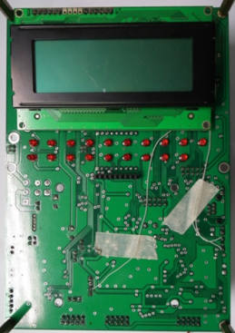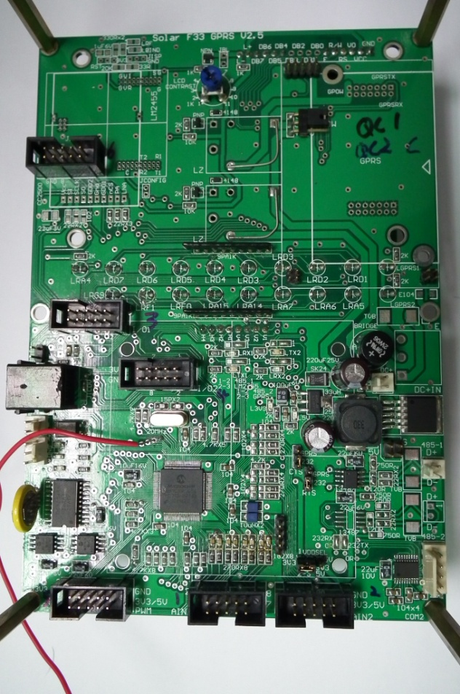

Figure 9 microprocessor core operations

**4.5 Web Based Battery Management Human Interface Design**

After the capture of the front-end capture circuit voltage and current analog signal into digital signal via the microprocessor's A / D, through DSPIC computing its actual voltage and current values ​​to ModBus protocol via RS485 serial data transfer to the database in their planning table fields as shown below:

Table 5 ModBus register Fields table

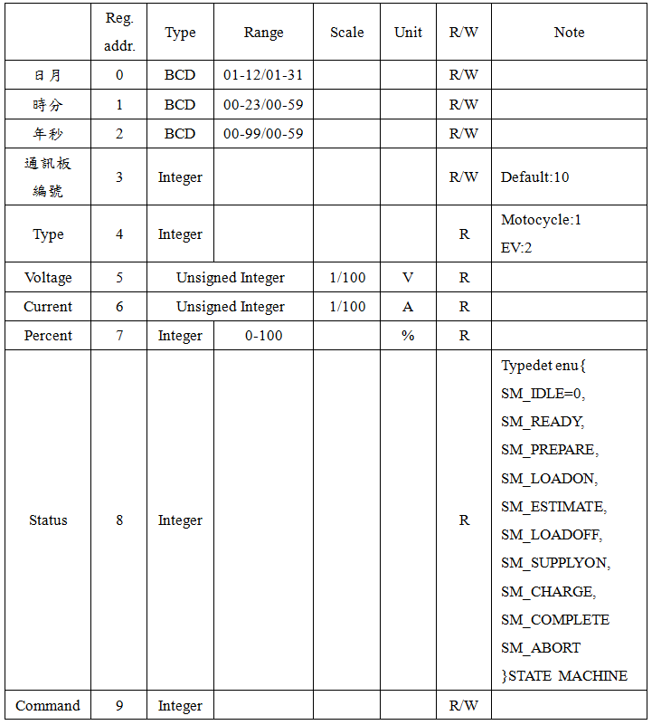

Lithium iron battery charge and discharge process, after determining the type of battery by microprocessor, web pages will be switched according to their type of battery to the car lithium iron battery or lithium iron batteries motorcycle display human-machine interface, and the kind of battery measurement information such as voltage, current and residual current battery charge% of real-time information displayed on the website is also currently in use to detect and update the website every 30 seconds of battery charge information and measurement curve.

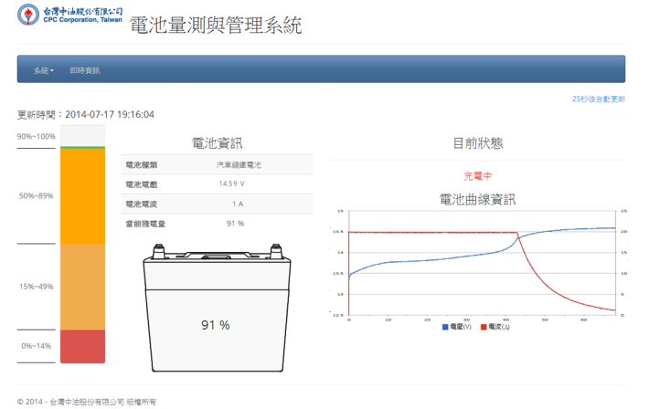

Figure 10 automotive lithium-iron battery of man-machine interface

Figure 11 locomotives lithium iron batteries HMI

**4.6 System Integration Test Results**

Battery capacity estimation using the proposed system architecture of the aforementioned lithium iron battery, the lithium-iron battery residual capacity estimation and increase the capacity of electricity estimates tired, experimental testing to verify this thesis developed residual power estimation system battery capacity charging system for estimating the actual charge, accuracy and feasibility of discharge situations.

Its steam locomotive charging current size for the next with a current, it is found that the value of the capacitance Ah battery charge (discharge) of electricity per minute, which is mainly used to charge a fixed amount (Ah) of lithium iron battery of tests per minute charge, the fixed initial capacity of each reference value (Ah), then closed loop discharge measured residual capacity, and residual capacity% against the value of the remaining capacity and the estimated time remaining after the discharge, and the actual lithium iron battery residual capacity and the estimated time of discharge were compared.

Table 6 car batteries each current charge (discharge) of the input (output) Ah value of electricity per minute

|  |  |  |
| --- | --- | --- |
| 充(放)電電流 | 20Ah汽車鋰鐵電池實際電流(A) | 輸入(輸出)電容量(Ah/分) |
| 0.3C | 6 | 0.1 |
| 0.5C | 10 | 0.1666 |
| 0.7C | 14 | 0.2333 |
| 1C | 20 | 0.3333 |

Table 7 locomotive batteries each current charge (discharge) input (output) Ah value of electricity per minute

|  |  |  |
| --- | --- | --- |
| 充(放)電電流 | 10Ah機車鋰鐵電池實際電流(A) | 輸入(輸出)電容量  (Ah/分) |
| 0.3C | 3 | 0.05 |
| 0.5C | 5 | 0.0833 |
| 0.7C | 7 | 0.1166 |
| 1C | 10 | 0.1666 |

**(1) a remaining battery power experimental test**

**1 car lithium iron battery residual power detection**

12, the testing process, the main analog electric vehicle remaining battery power of 25% or less was evaluated in and verify the accuracy of the estimate by the residual charge.



Figure 12 car lithium-iron battery residual charge of the experimental flow chart

The charging current at different test results are shown in Table 8, the battery capacity is estimated by%, to convert it to estimate the value of the capacity Ah discharge time, which estimates the value of the reference discharge capacity during the experiment, and finally with output capacity of comparing the actual discharge capacity error.

Capacity error% = (actual output capacity (Ah) - estimate the capacity (Ah)) / (actual capacity and out (Ah)) \* 100% (2) = $\frac{實際輸出電容量(Ah)-估測之電容量(Ah)}{實際出出電容量(Ah)}*$ 100% (2)

Table 8 car batteries in a variety of current charging the battery residual capacity measurement results

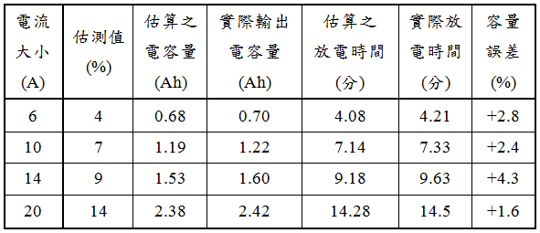

**2 motorcycle lithium-iron battery residual power detection**

Testing process in Figure 13, and the estimated value and the actual capacity Ah discharge capacity compare the error as shown in Table 9, the experiment can be learned from the error range were less than 5%, it verifies the accuracy and feasibility of methods .



Figure 13 locomotives residual capacity lithium-iron batteries experimental flow chart

Table 9 motorcycle battery charged at 0.5C to preset residual power of time measurement results

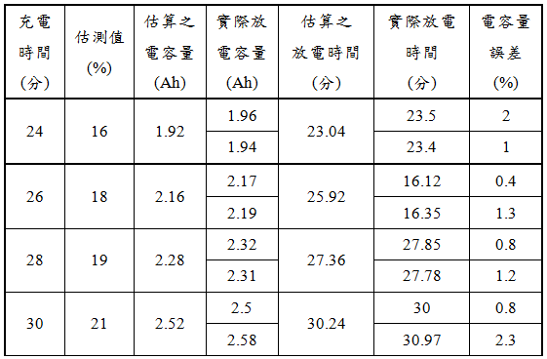

**(2) Battery tired incremental experimental test**

1 car lithium-iron battery tired increment detection

After the test flow shown in Figure 14, the initial setting is fixed to a preset residual battery charge and discharge to a cut-off time, and the results are shown in Table 10 finishing.



Figure 14 lithium-iron battery car tired incremental flow chart of the experiment

Table 10 car batteries with different charge current tired incremental measurement results

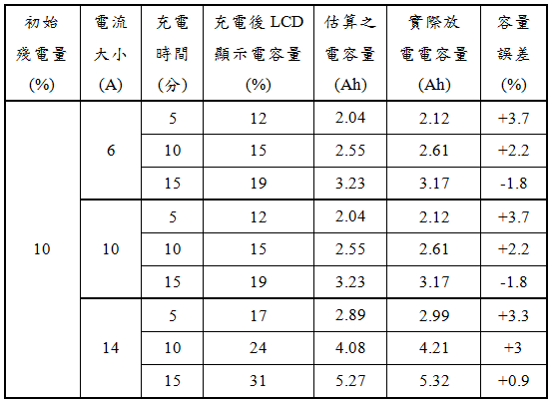

Finally, the experimental estimate of the actual discharge capacity Ah capacity compare the error, the error range were less than 5%, it verifies the accuracy and feasibility of its methods.

**5 Conclusions**

Due to the variety and the different characteristics of the battery, so this paper uses high current charging and discharging and good conversion efficiency and widely used in the electric car's lithium-iron battery test, the type is divided into automobiles, motorcycles lithium-iron batteries.

In this paper, the use of closed-loop load voltage method with a lookup table with the Coulomb residues were detected by battery power and tired incremental, verified by experiments that estimate the residual battery power and increase the capacity of its cumulative error were less than 5%, the error sources only for the design of precision integer bits, can not handle decimal place following the measurement results, and the battery due to aging or environmental factors that caused the accident.

Finally, through the microprocessor-based estimate of the residual power and tired incremental firmware design and capture circuit voltage and current data collection and transfer of information through the measurement cell Modbus protocol to Web Based HMI in battery management, allows users to understand the current battery charge real-time information, it is a good battery capacity estimation system can improve the accuracy of detection of the battery capacity.

**References**

[1] AG Ritchie, "Recent developments and likely advances in lithium rechargeable batteries", Journal of Power Sources, vol.136, pp.285-289, 2004.

[2] Tsutomu Ohzuku and Ralph J. Brodd, "An Overview of positive-electrode materials for advanced lithium-ion batteries", Journal of Power Sources, vol.174, pp.449-456, 2007.

[3] "lithium iron battery performance and principle", internet: http://www.elecfans.com/yuanqijian/dianchi/lidianchi/2009102398842.html, August, 2013

[4] Lin Zuowei, battery detection techniques of research, National Taiwan University, Master's thesis, 2001.

[5] Pedersen, GA, "The use of ratiometric measurement to determine battery status", IEEE INTELEC, pp.491-496, 1994.

[6] Aylor, JH, Thieme, A., Johnso, and BW, "A Battery State-of-charge Indicator for Electric Wheelchairs '', IEEE Transactions on Industrial Electronics, vol.39, No.5, pp.398- 409, 1992.

[7] Zhang, the study estimates the electric car battery residual charge of National Changhua University Master's thesis, 2001.

[8] Ye Jiaming, DSP-controlled intelligent power management unit of the National Sun Yat-sen Master's thesis, 2003.

[9] Zhengfu Gang, intelligent motor vehicle residual electric charge management and diagnosis, master's thesis, National Sun Yat-sen, 2001.

[10] Chen, HL, "A new battery model for use with battery energy storage system and electric vehicles power system '', Power Engineering Society Winter Meeting IEEE, vol.1, pp.470-475, 2000.

[11] Yen positive slope to the discharge voltage instantaneous estimation methods for the study of lithium iron phosphate battery residual capacity of the foundation of the National Kaohsiung University of Applied Science and Technology Master's thesis, 2012.

[12] Lai Shirong, smart lithium-ion battery research to estimate the remaining charge, Zhongshan University Department of Electrical Engineering Master's thesis, 2004.